**Project Log Book**

This log book is a compilation of images showing rough notes taken by the team during the course of the project.

**Database Sketch**

Below is a sketch the team developed of the two tables we thought would be necessary in the application and how they would link.

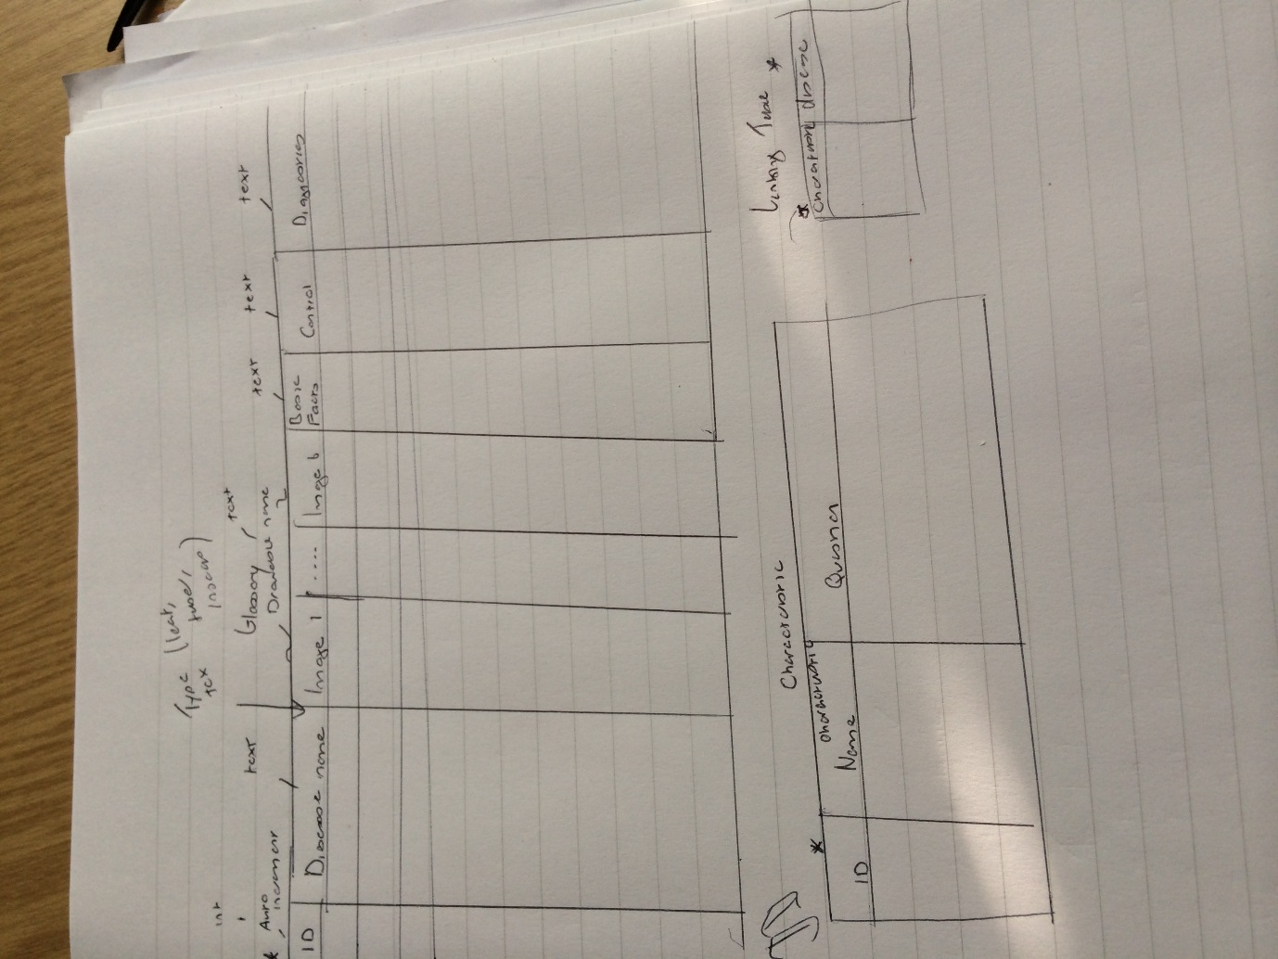

**Glossary Sketch**

Below is an image of the teams sketch for the glossary page of the application sketched at the beginning of the project.

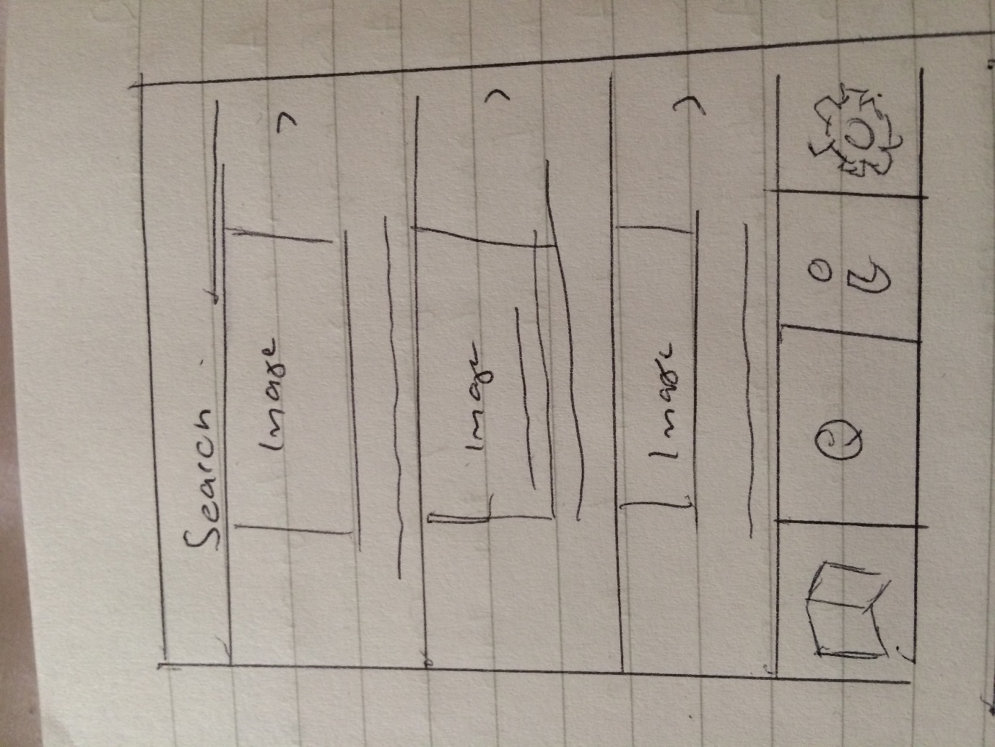

**Further Info Page Sketch**

Below is an image of the further information page the team sketched out at the beginning of the project.

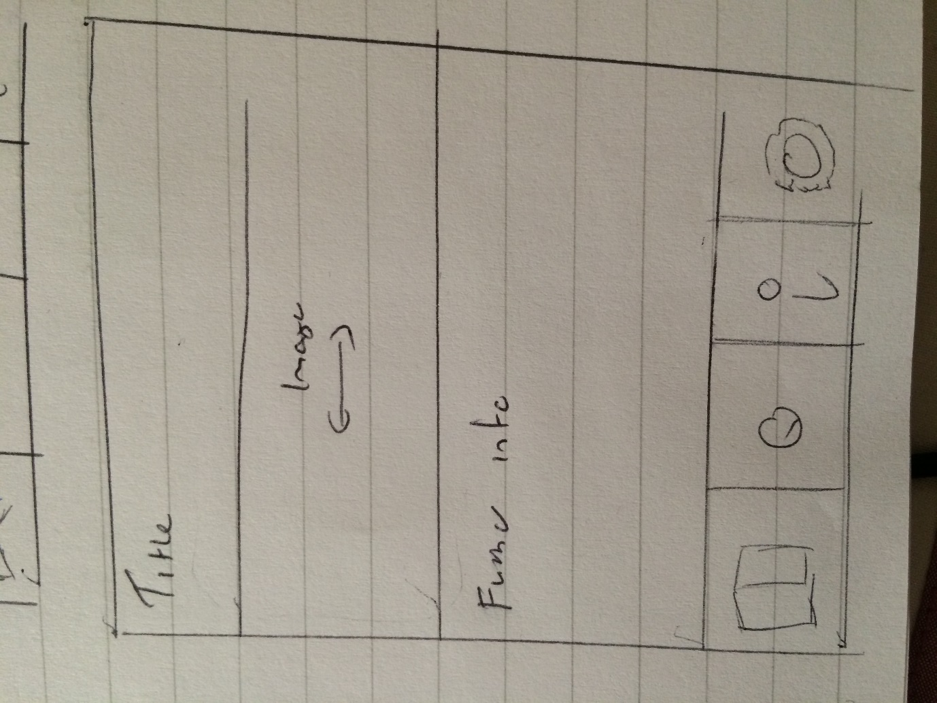

**Expert system sketch**

Below is an image of a sketch the team made of what the expert system should look like.

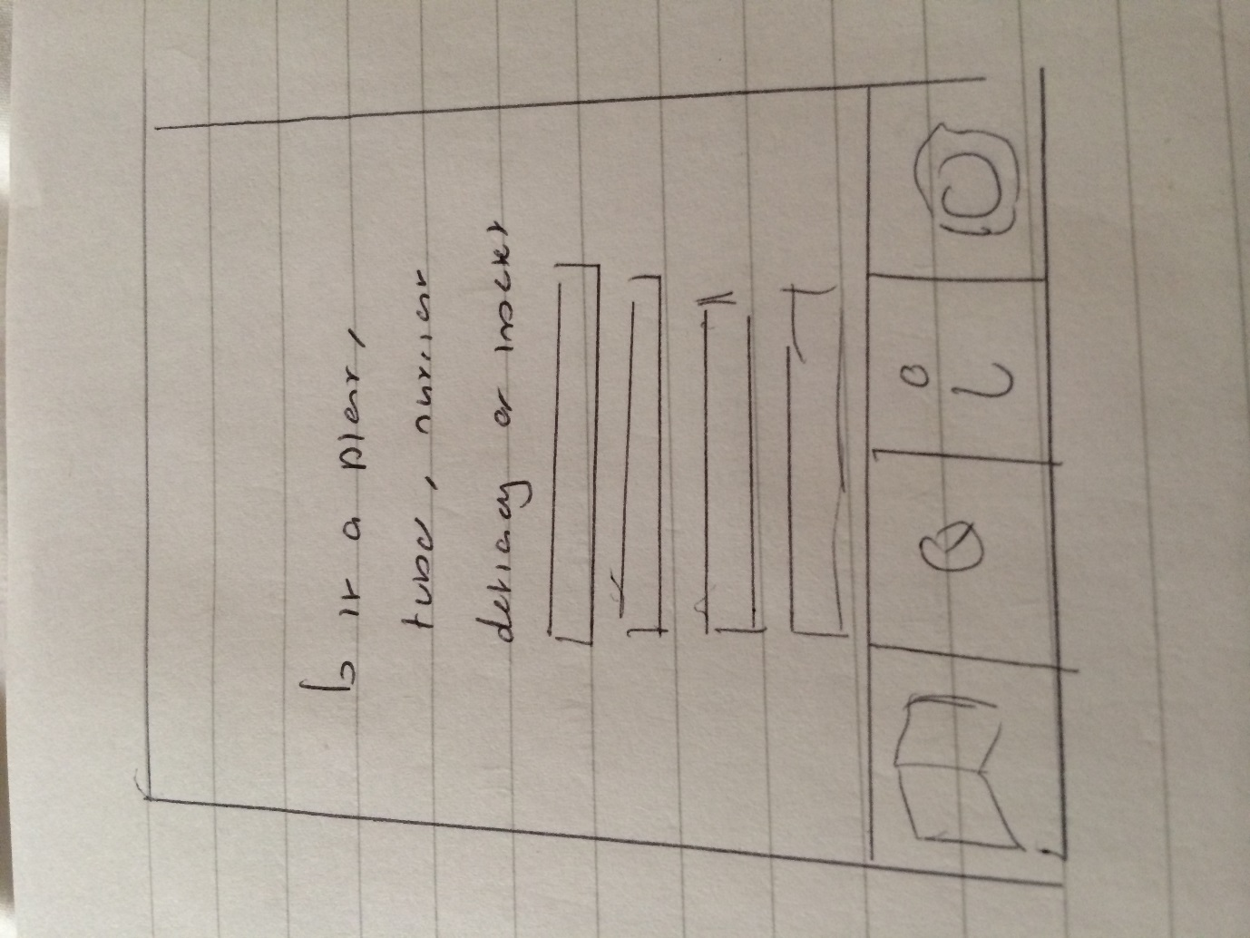

**Video Page Sketch**

Below is an image of the video page sketch from the beginning of the project.

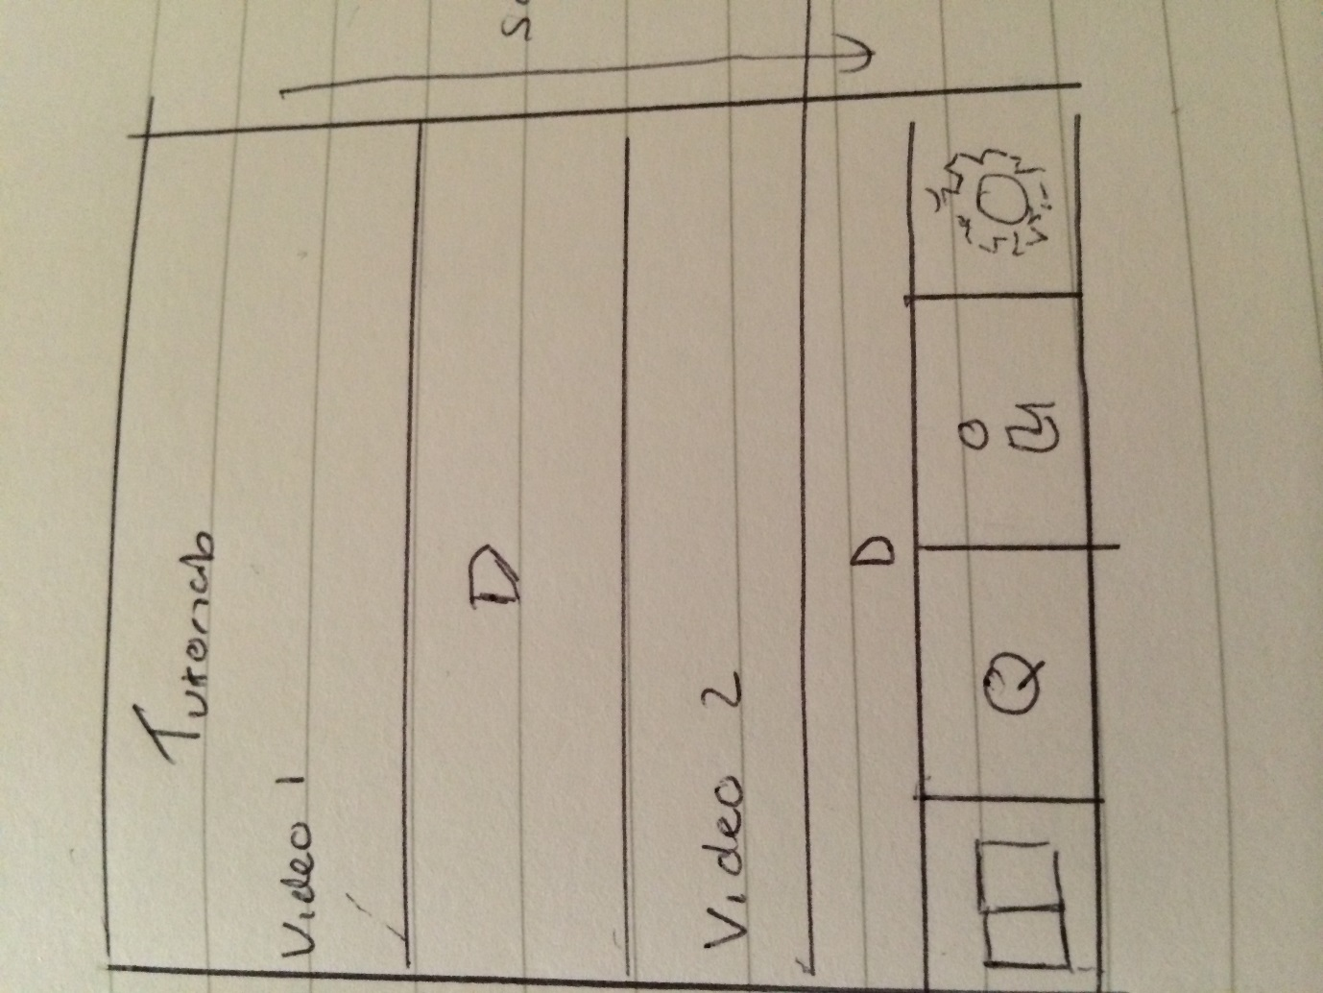

Original requirement notes after initial client meeting

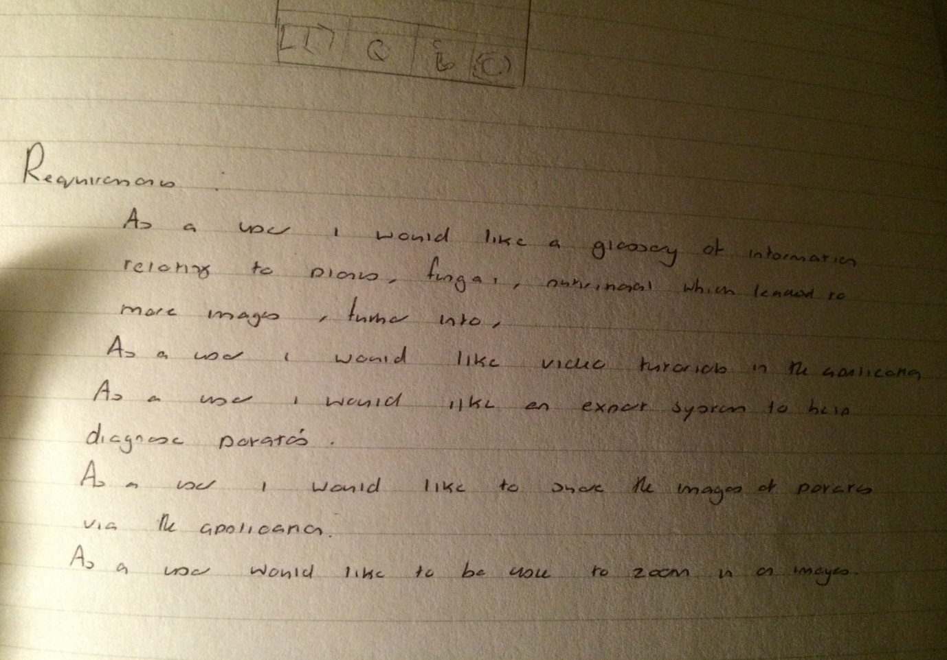

Requirements refactored notes after discussions

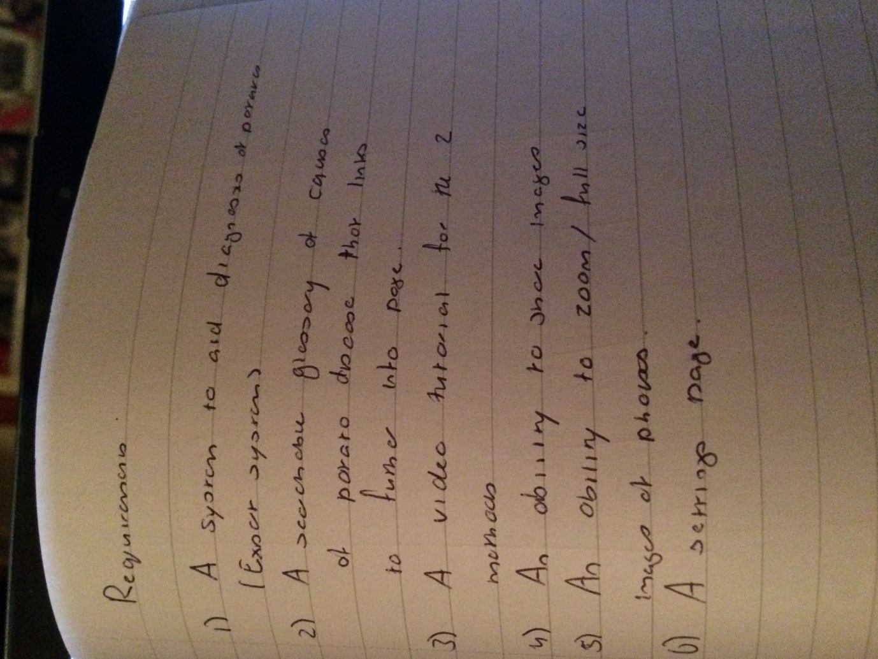

Website and application communication sketch for ideas of how we would update and insert information into the application

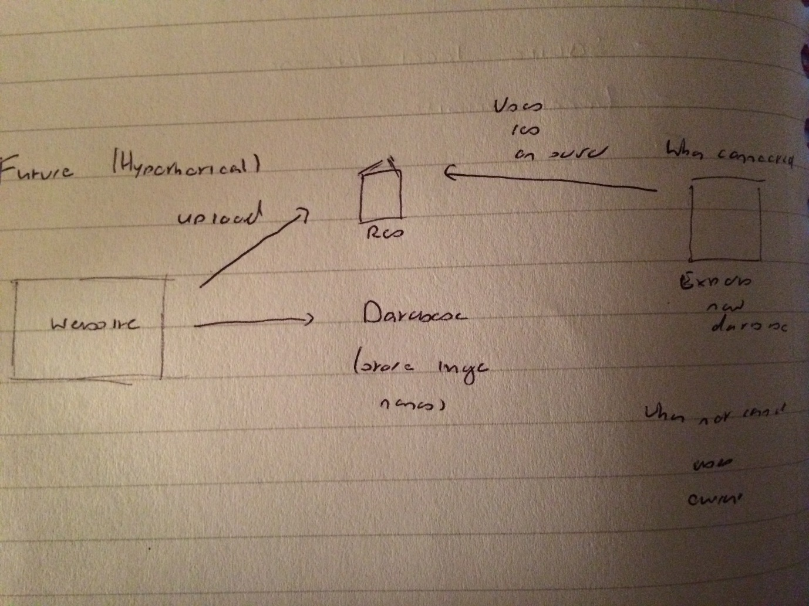

A detailed sketch of the columns in the glossary table

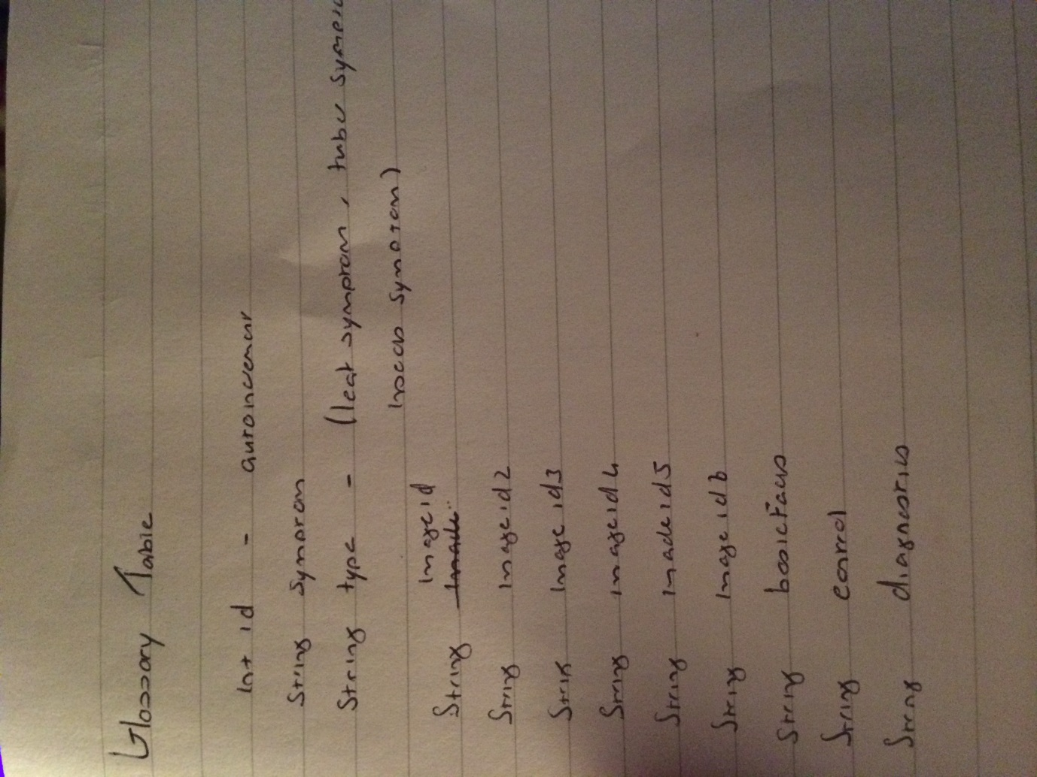

Research into how the database will work with images

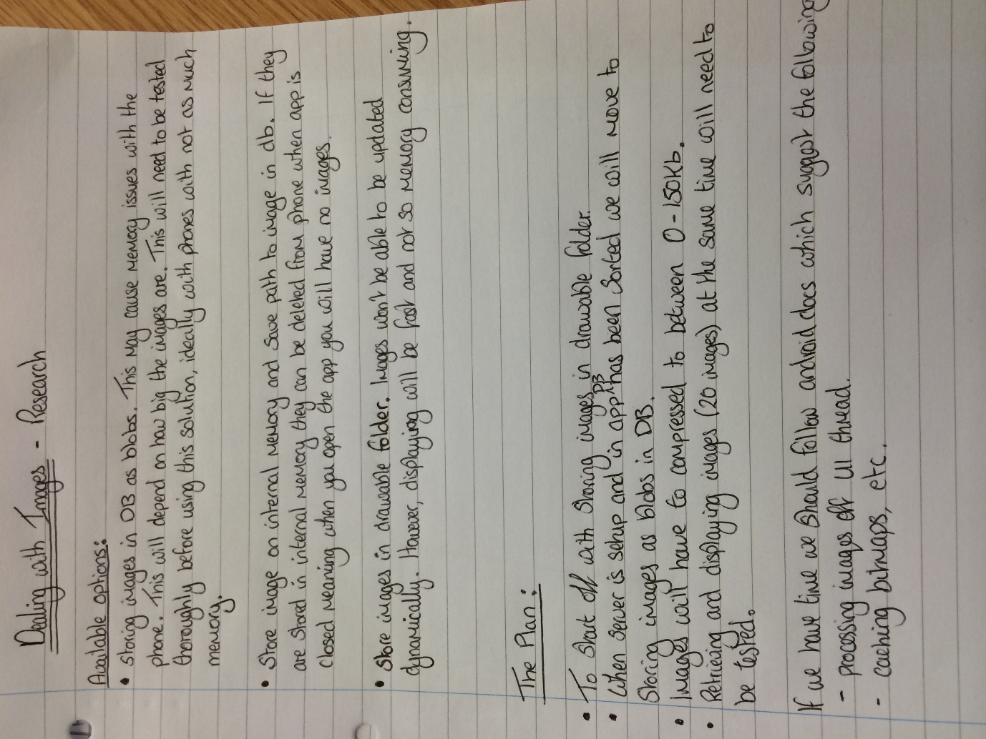

Mark’s application design sketches

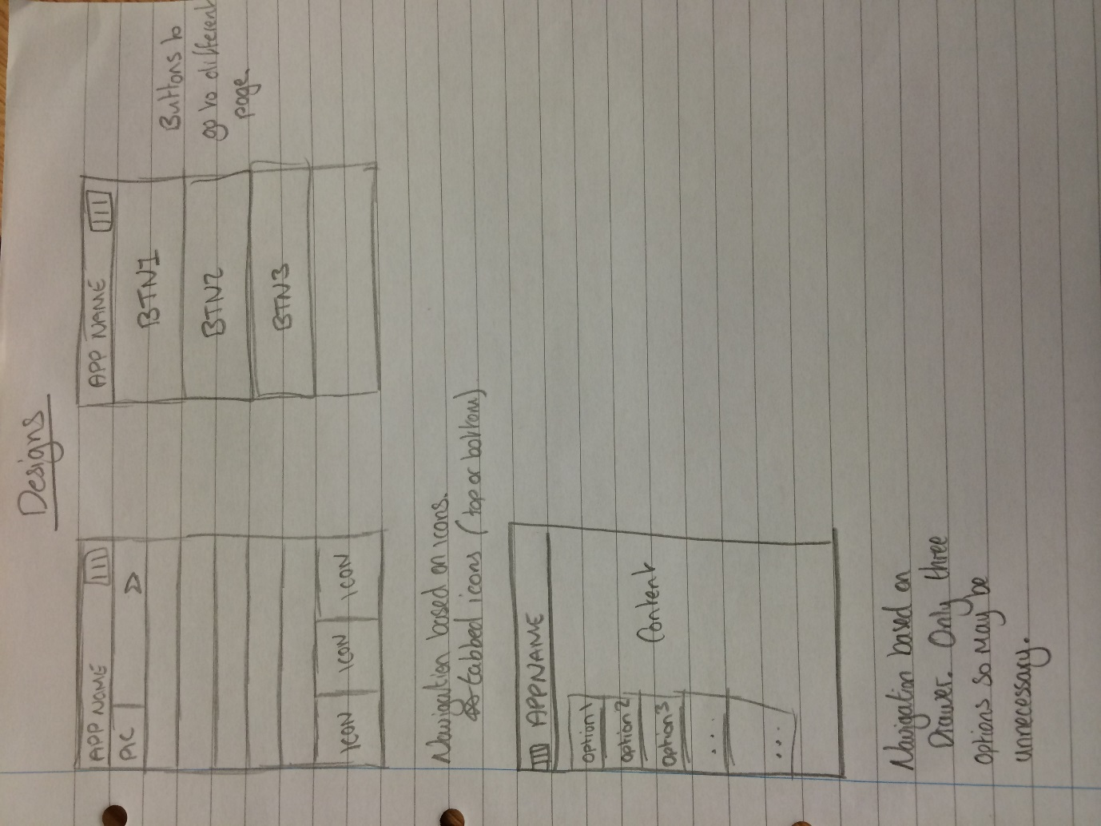

Github has a log of the work we have been doing over the project this can be found here <https://github.com/karivmcmahon/IndustrialTeamProj> and can be seen via the commits.